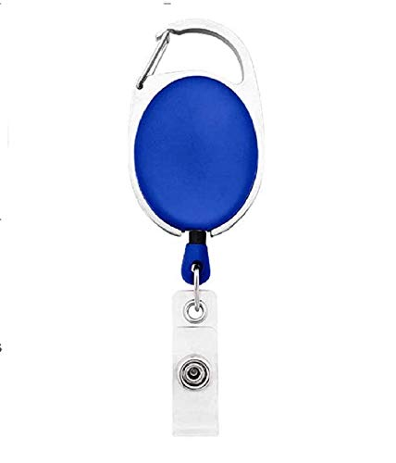

EMPLOYEE CARD

***EMP1367***

|  |  |
| --- | --- |
| **CLAIRE ABBOTT** | PHOTO |
| **Database** |
| **Joining:03/22/2022** |
| **Blood Group:O+VE** |
| **Phone:9832675438** |

www.companywebsite.com